**Lab – 2: How to get started with Microsoft Azure?**

**Objective:** The objective of this lab is –

* To get started with Microsoft Azure.

For managing Enterprise Mobility + Security we require access to the Microsoft Azure Portal. So, in this lab, we are going to start with Azure Portal.

**Prerequisite:** EMS Enterprise Mobility + Security E5 Trial.

**Steps:**

1. After creating an account for EMS, open a link - **https://account.azure.com/Home/Index**, and click on **Sign In** option at the top right corner.

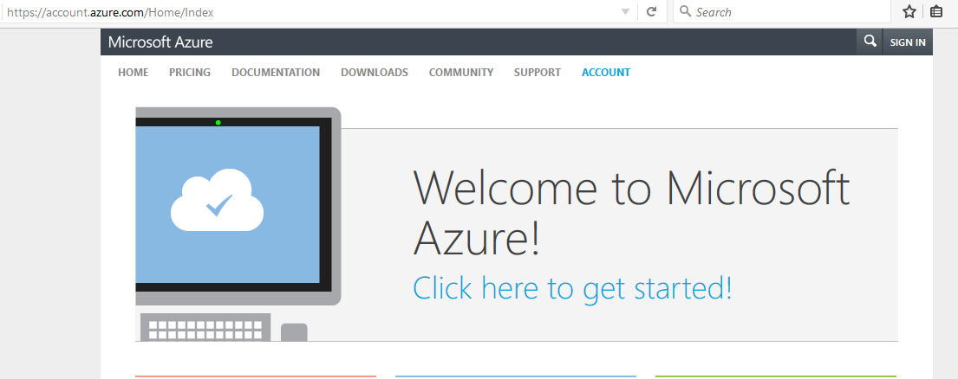

1. Enter your credentials that you have created while registering for **EMS**. And, click **Sign In**.

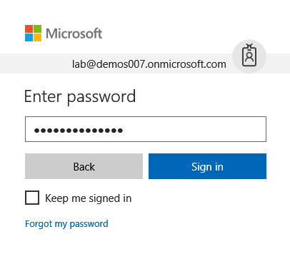

1. Click on **Portal**.

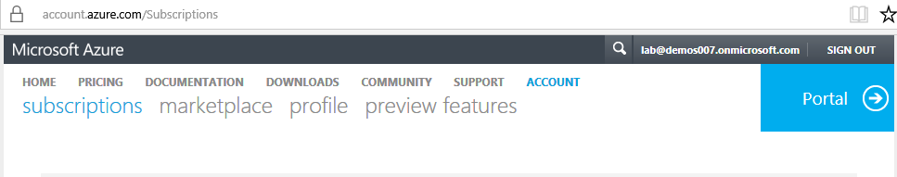

1. Now, you are getting logged in to **Microsoft Azure Portal**.

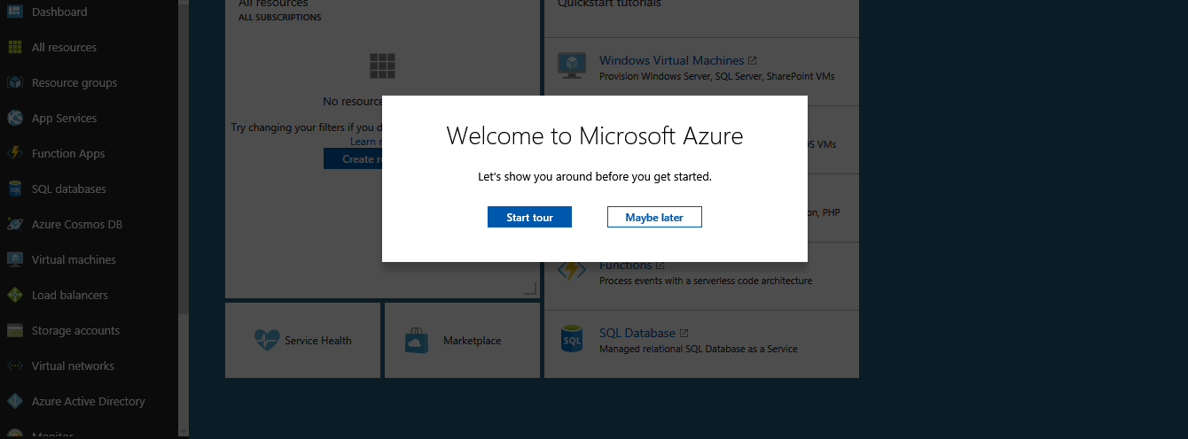

1. For better understanding, you can start the tour of Microsoft Azure Portal. Click on **Start tour**.
2. A **new** option, from where you can quickly create a resource, or just view the wide variety of services in the Azure Marketplace. Then, click **Next**.

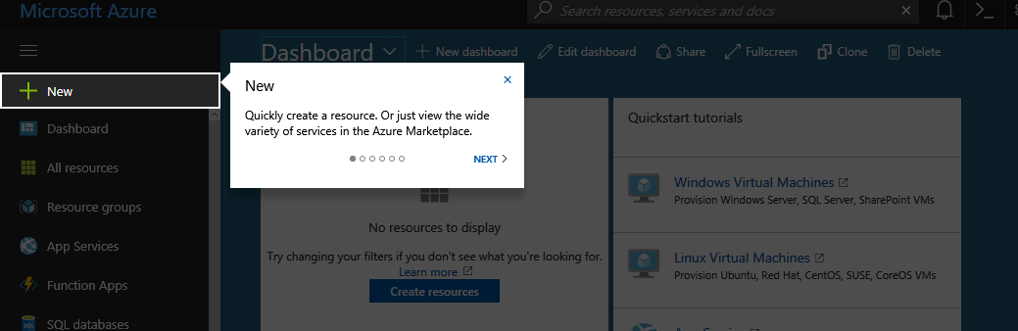

1. **Browse + Favorites** will show, from where you can browse all your favorite services. And, to modify your favorites, select “More services” and toggle the star icons.

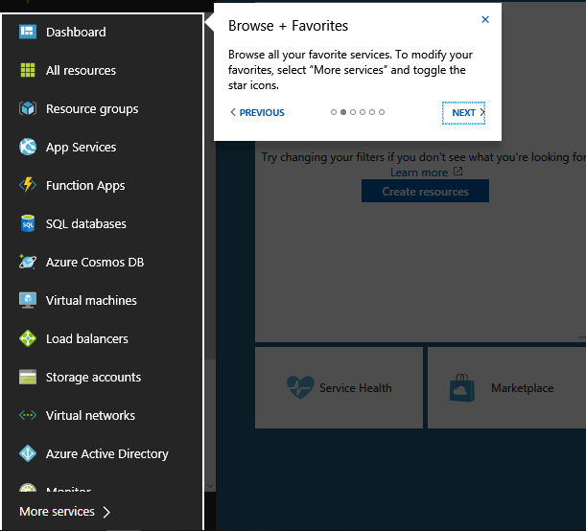

1. Then click **Next**, and you will get **Search** option, from where you can quickly find resources that you are looking for. Then click **Next**.

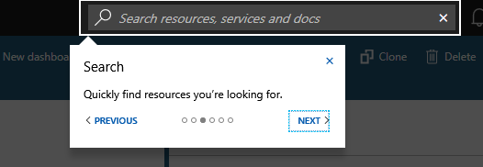

1. You will get the **Notifications** area, from where you can view status updates and other information. Then click **Next**.

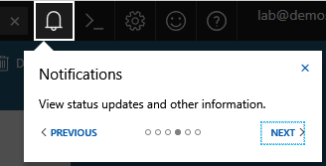

1. This is the **Help + Support** area from where you can get help or open a support request. Then click **Next**.

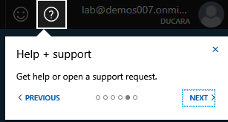

1. From here, you can get the **Account Information**, from where you can switch directories, change the password, view your permissions, submit an idea or view your bill. Then, you can click **finish**.

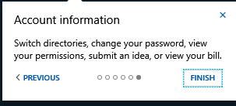

1. So, this is how you can get started with Azure Portal.